*Pac-Man*

*In this project you will create a Pac-Man game in Scratch that is able to learn from how you play. 本次任务，你将在脚本中自己创作吃豆小精灵游戏，小精灵将会通过你的数据进行学习。*

*You won’t give it instructions for how to play, or tell it what the objective or rules of the game are.你不需要做出任何指示，给出任何规则。*

*Instead, you’ll show it examples of you playing the game. 你的游戏数据将会成为它学习的资料*

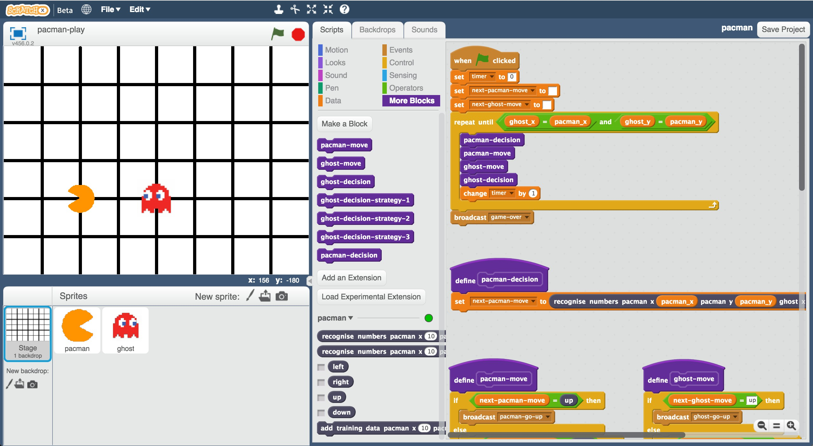

This project worksheet is licensed under a Creative Commons Attribution Non-Commercial Share-Alike License <http://creativecommons.org/licenses/by-nc-sa/4.0/>



1. Go to https://machinelearningforkids.co.uk/scratchx in a browser.

浏览器打开网址machinelearningforkids.co.uk

1. Open the **Pac-Man** template for this project. 打开吃豆小精灵工程模板

*Click* ***Project templates*** *->* ***Pac-Man* 点击工程模板->吃豆小精灵**

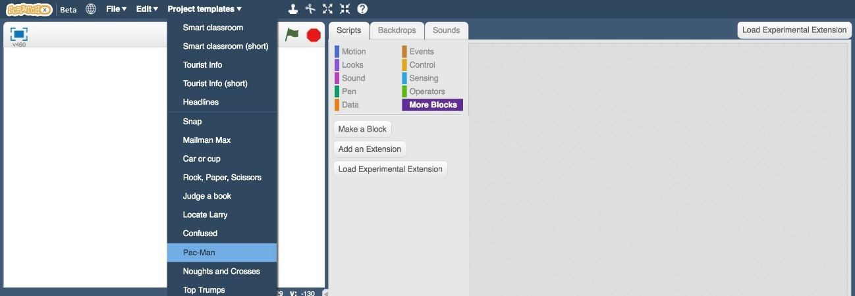

1. Click the **full-screen** button, and then click the Green Flag

点击**全屏**按钮 点击绿色旗子

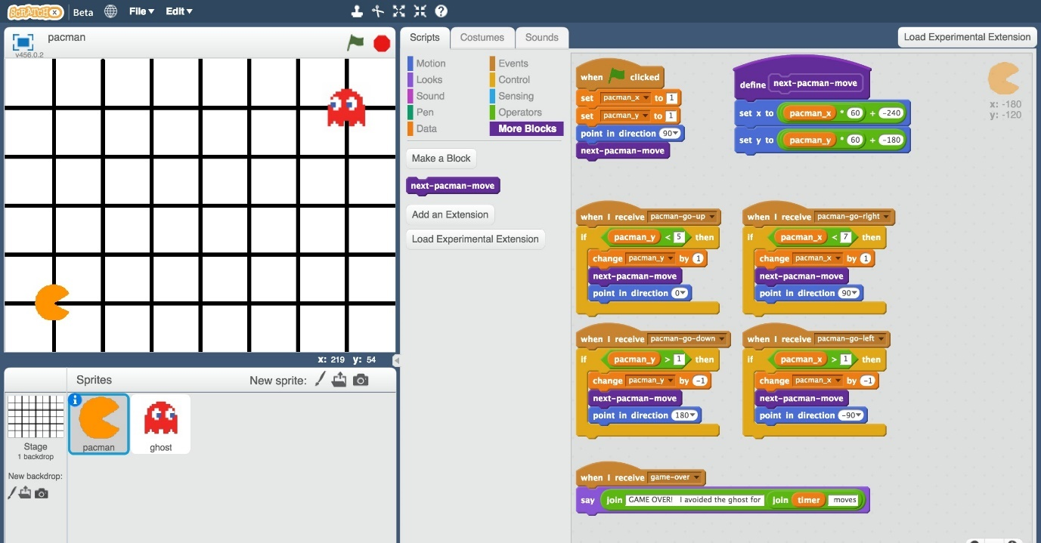

1. Play a few games of Pac-Man 玩几次游戏

*You control Pac-Man, and have to avoid the ghost as long as you can.*

*Use the arrow keys to control Pac-Man’s next move. Click the green flag to start a new game.*

*控制小精灵，你要尽力避开幽灵。用方向键控制小精灵，重新开局点击绿色旗子按钮。*

1. Try to come up with a plan for how Pac-Man can avoid the ghost

想办法避开幽灵

Representing Pac-Man in Scratch

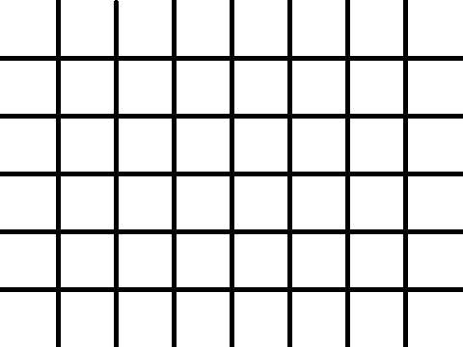

5

*values*

4

3

2

*y*

1

1 2 3 4 5 6 7

x values （x值）

在脚本中定位小精灵

The game board is a graph, with both Pac-Man and the ghost only able to travel along lines. 游戏背景是一个图表，小精灵和幽灵只能在线上运动

The location of each character is stored as: 各角色的坐标是

* an x-value (a number from 1 to 7)
* x轴坐标（数字1-7）
* a y-value (a number from 1 to 5)
* y轴坐标（数字1-5）

For example, the ghost shown on the left is at:比如幽灵的坐标

X = 5

Y = 2

Up上

At each turn, each character has to choose between four possible moves: up, down, left, right.

每一步后，角色都要选择下一步方向：上下左右

There are no diagonal moves. 不能走对角线

Left左 right右

down



下

**What are you going to do? 你要做什么**

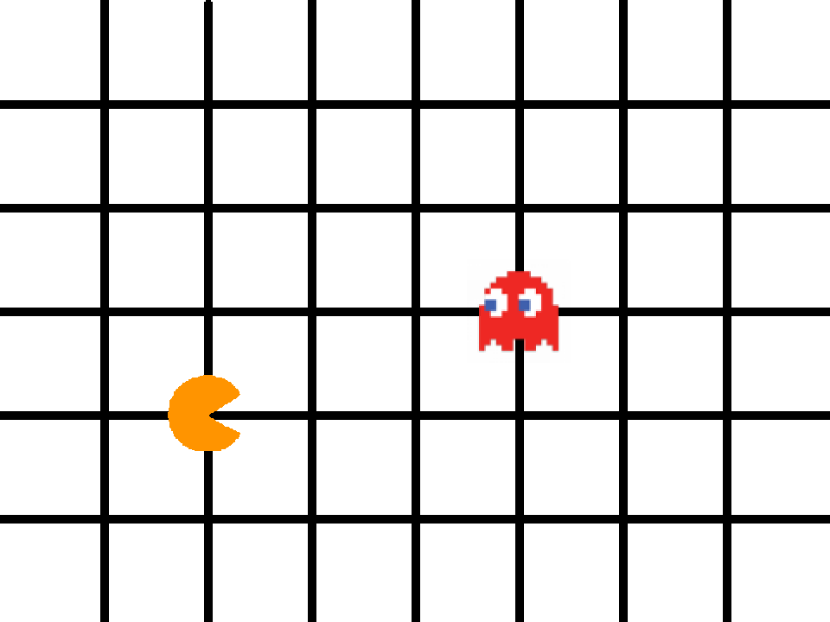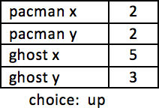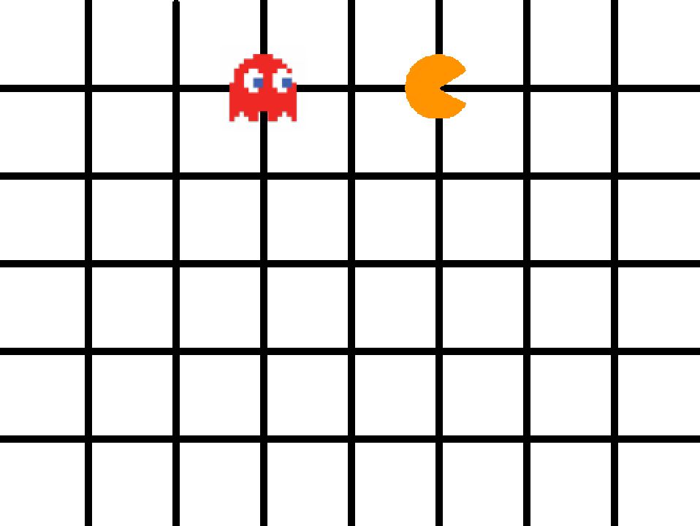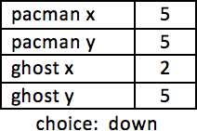

You’re going to train Pac-Man to avoid the ghost. You’ll do this by showing it examples of how you play the game. 你要训练小精灵躲避幽灵。你的游戏数据会成为学习材料

Imagine the board looks like this:

想像这样的情景

Imagine you decide to go up: 你决定向上走

Imagine the board looks like this:

想象这样的情景

Imagine you decide to go down:

你决定向下走

The computer will learn from the decisions that you make when you play the game. 你的游戏数据会成为学习材料

That means if you make moves that avoid the ghost for a long time, the computer should learn how to avoid the ghost! 如果你能长期躲避幽灵，电脑通过学习也可以做到这点。

1. Close the Scratch window. 关掉脚本窗口
2. Go to https://machinelearningforkids.co.uk/ in a web browser 用浏览器打开网址
3. Click on “**Get started**”

点击“开始”

1. Click on “**Log In**” and type in your username and password

*If you don’t have a username, ask your teacher or group leader to create*

*one for you.*

*If you can’t remember your username or password, ask your teacher or group leader to reset it for you.*

*点击****“登录”*** *输入用户名与密码。如果你没有用户名，让你的老师和小组组长为你创建一个。如果你记不住用户名或者密码，让你的老师或小组组长为你重置。*

1. Click on “**Projects**” on the top menu bar 点击菜单上方的**“项目”**
2. Click on the **“+ Add a new project**” button. 点击“**添加新项目**”按钮
3. Name your project “pacman” and set it to learn how to recognise “**numbers**” 将项目命名为小精灵，将其设置识别为**“数字”**

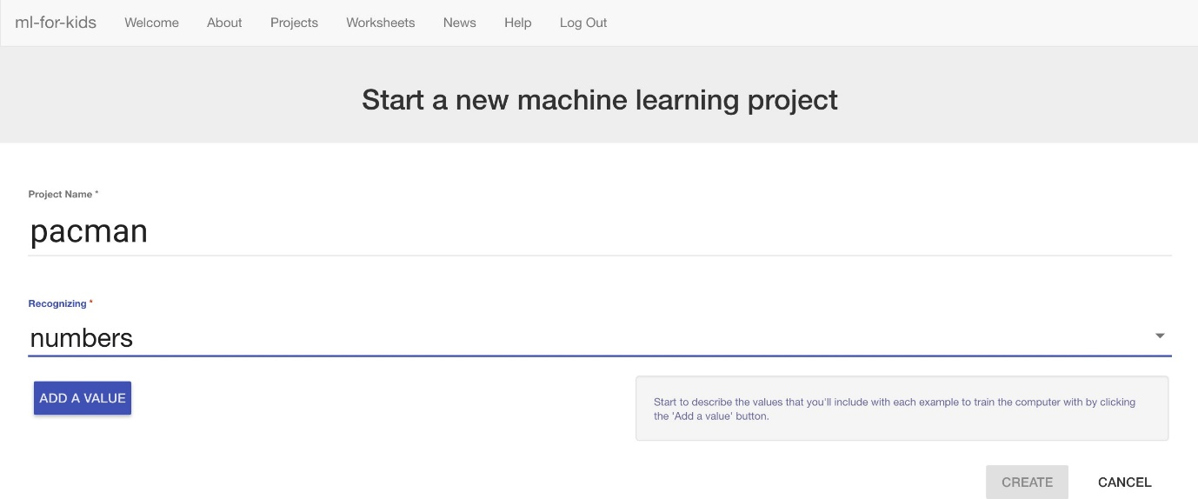

1. Click “**Add a value**” and name a value “pacman x” and make it a “number”.

点击“**添加值**”并将其命名为“小精灵x‘将其调整为”数值型”

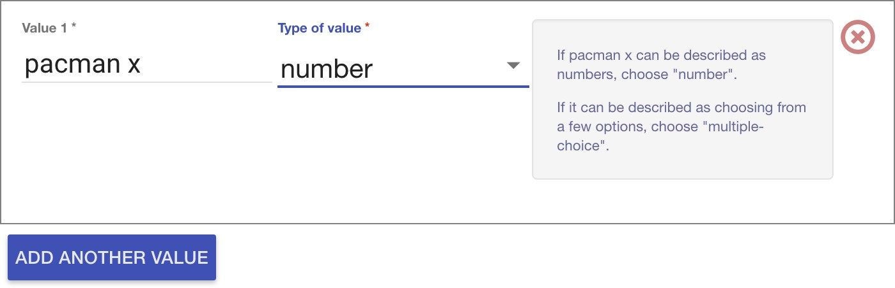

1. Click “**Add another value**” again and repeat to add values for the other three positions: “pacman y”, “ghost x”, “ghost y” 再次点击**“添加值”**按照上述做法，创造“小精灵y” “幽灵x”，“幽灵y”

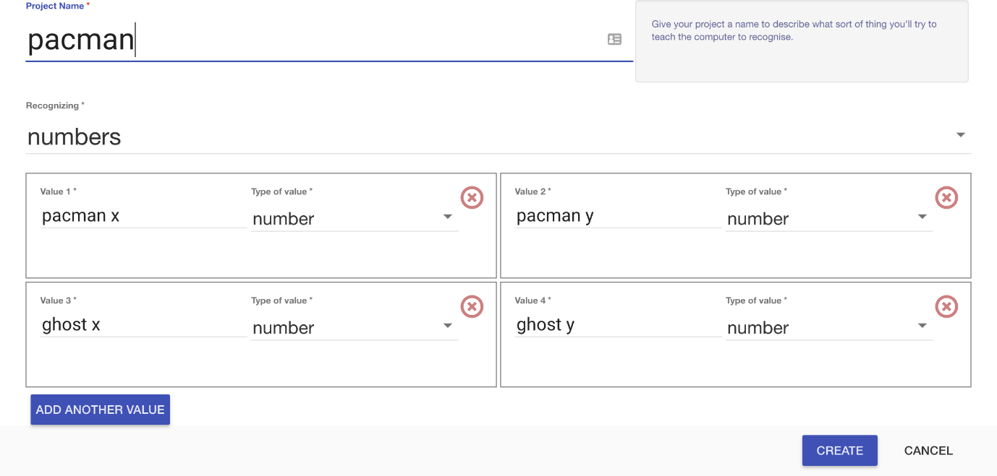

1. Click **Create**. 点击**创造**
2. You should see “**pacman**” in the list of your projects. Click on it.

你会在目录中看到“**pacman**” 点击它

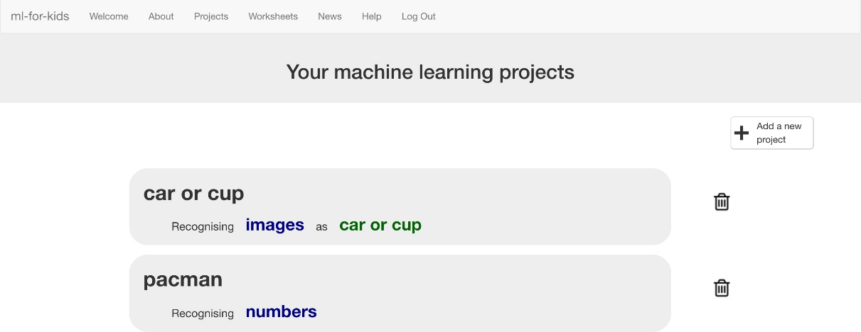

1. Click the “**Train**” button 点击“**训练**“按钮

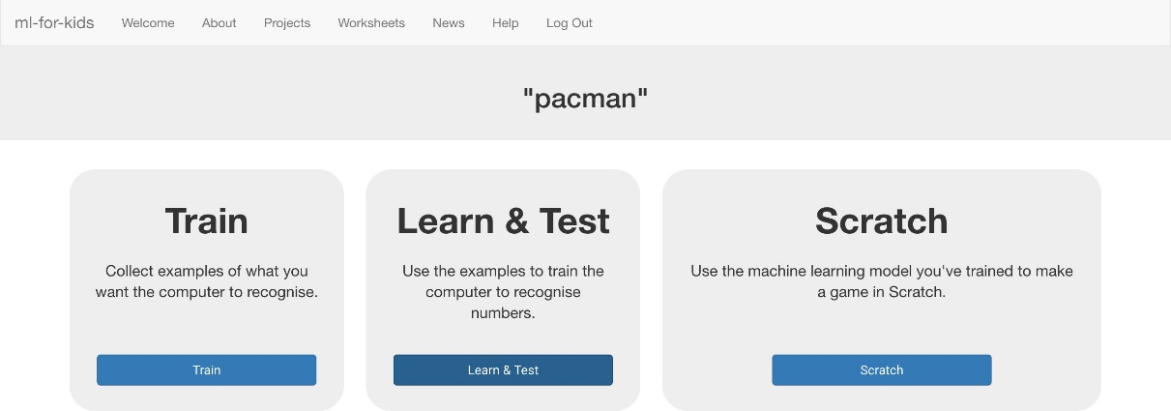

1. Click “**+ Add new label**” and create a label called “left”

*Examples of the locations of the Pac-Man and ghost when you go left will*

*go in this bucket.* 点击“**添加新标签**“，将其命名为”左‘。当小精灵和幽灵向左走时他们的坐标将会被记录在下面的框之中。

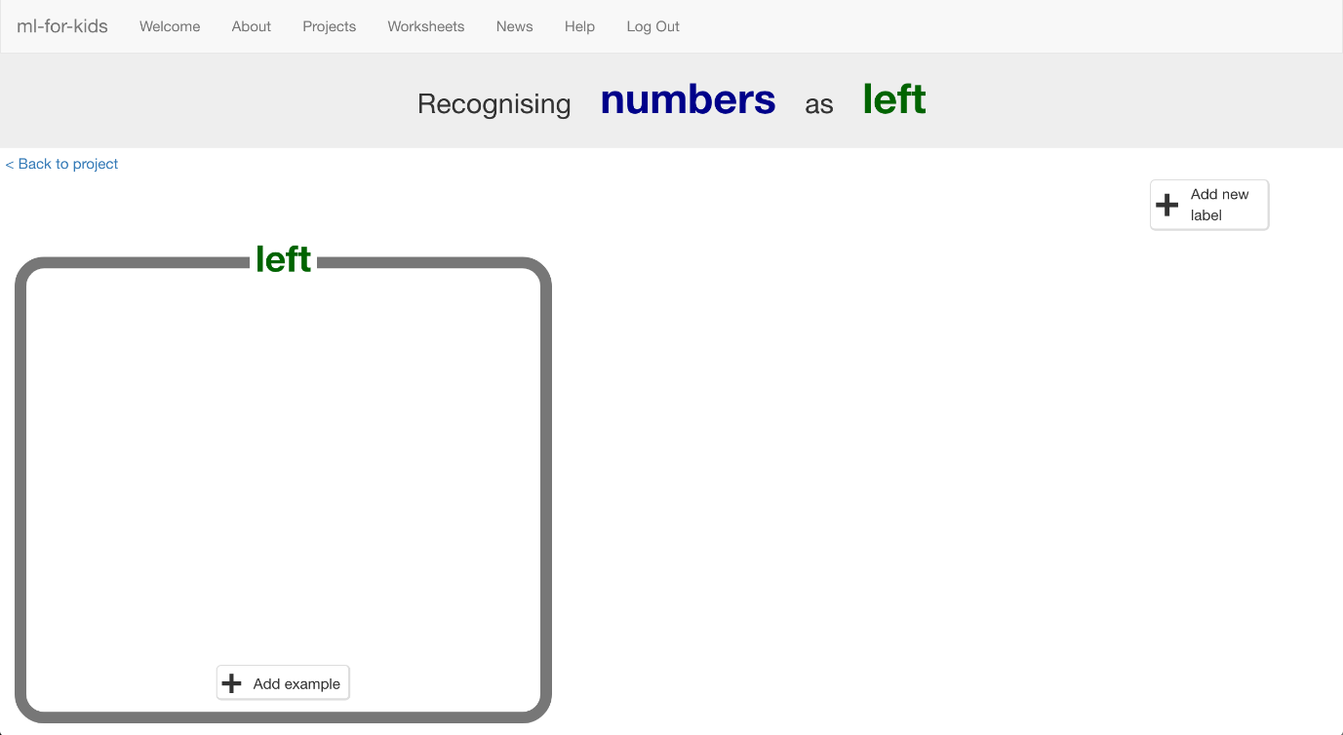

1. Click “**+ Add new label**” again and create labels for the other three moves in the game. 再次点击 “**添加新标签**“，为其他三个方向制作标签。

*“right”, “up”, “down”*

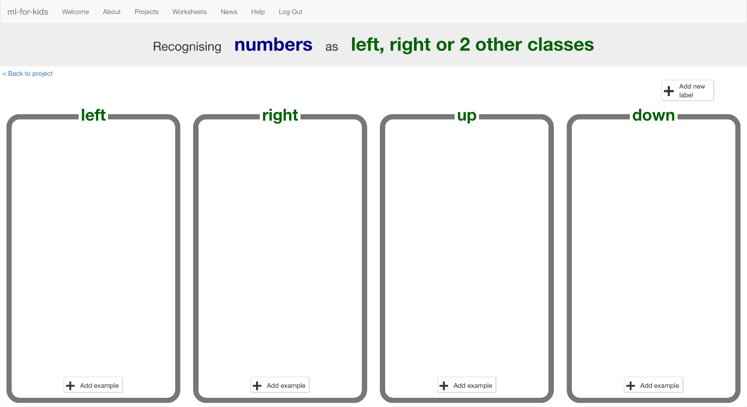

1. Click the “**< Back to project**” link then click **Scratch** 点击**“回到项目”**链接再点击**脚本**
2. Click the **Open in Scratch** button 点击**打开脚本**

*It will warn you that you haven’t trained the computer yet – but that’s*

*okay, as you’ll use Scratch to collect the training examples. Click the “****go straight into Scratch now****” link.*

*他会提醒你还未训练计算机。但没有关系，因为你用脚本收集数据。点击““****go straight into Scratch now*** *“链接*

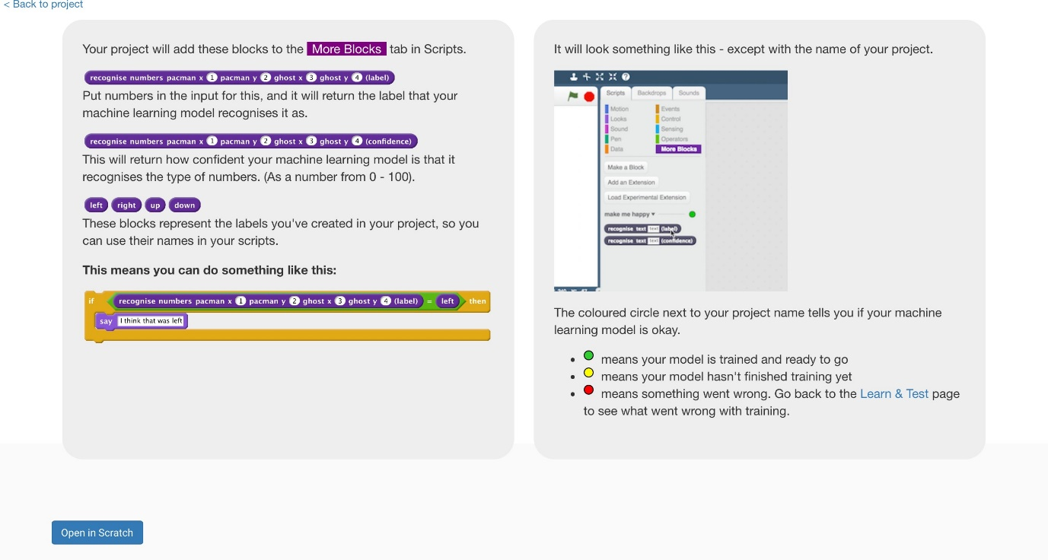

1. You should see new blocks in the “**More blocks**” section from your “pacman” project. 你能在“**more blocks**“中找到新的语句块

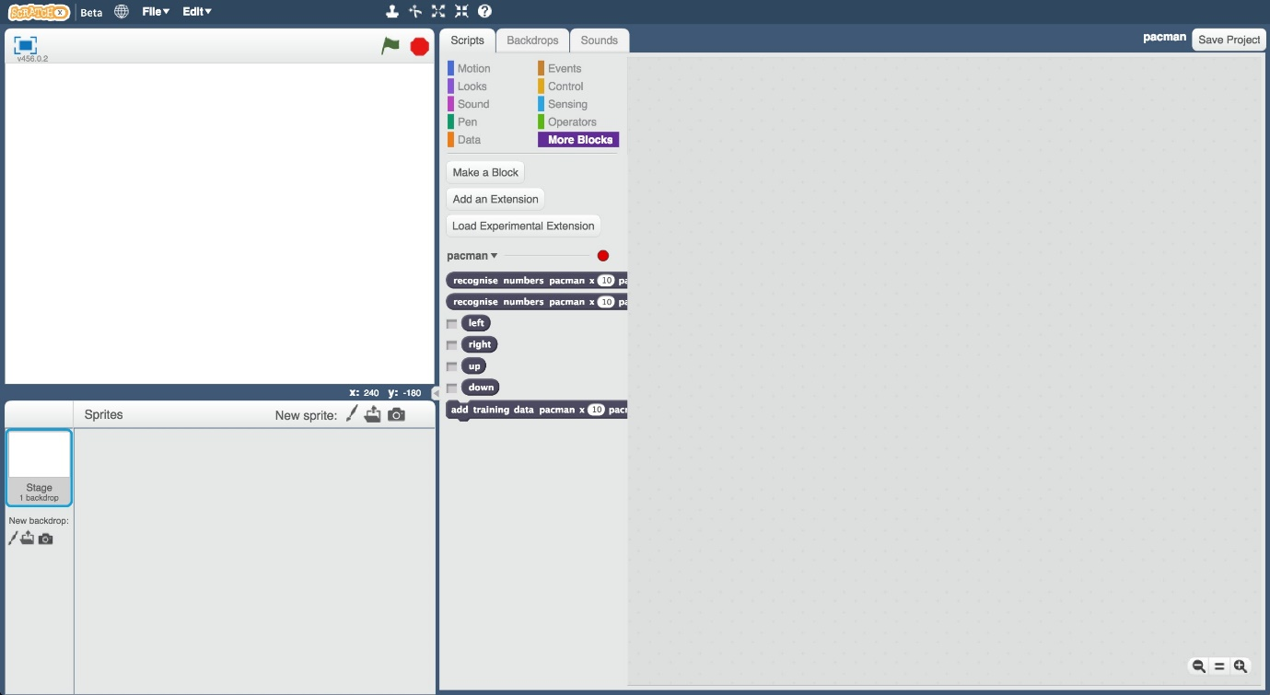

1. Open the Pac-Man template project again. 再次打开项目模板

*Click* ***Project templates*** *->* ***Pac-Man*** *点击****project template*** *->* ***pacman***

1. Click on the “**Stage**” 点击“**stage**“

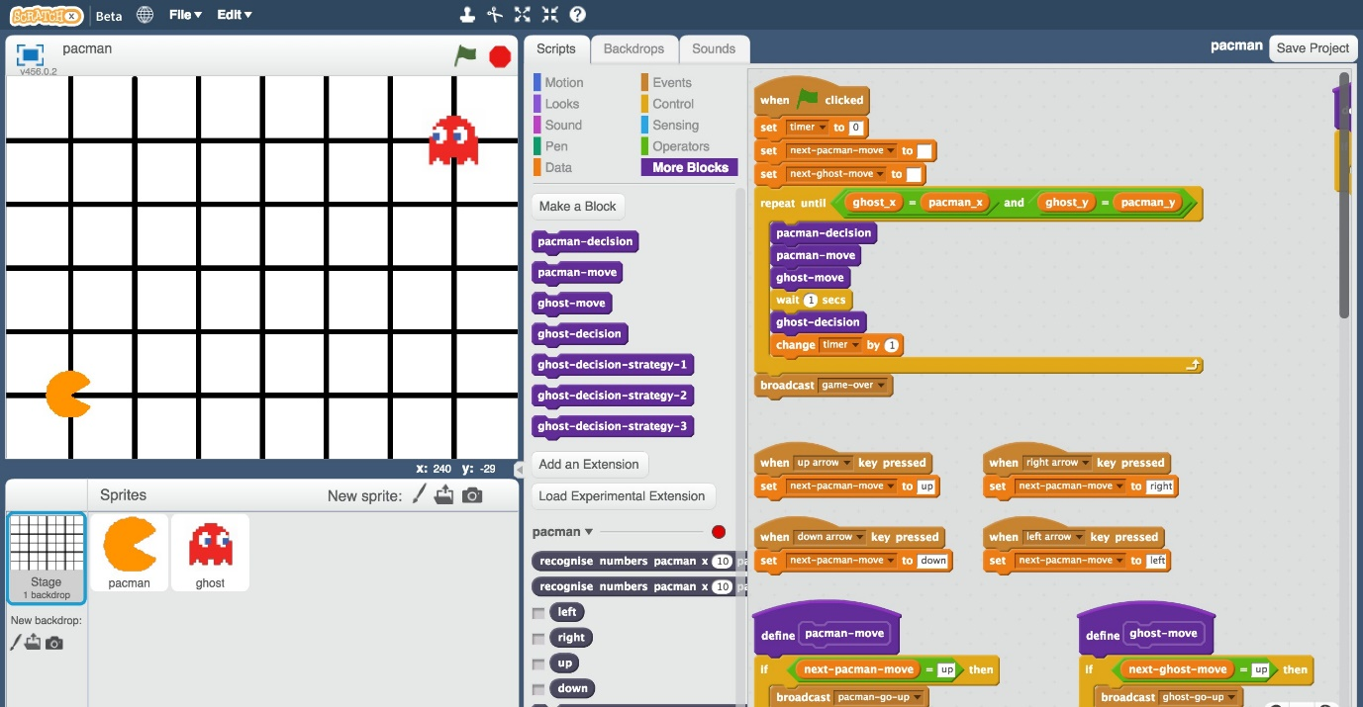

1. Modify the key press scripts to use the move choices you created *Drag the “up”, “down”, “left” and “right” blocks from your “pacman” project into the boxes in the scripts like in the picture below.*

*You don’t need to add these scripts – you just need to drag in the dark blue “up”, “down”, “left”, “right” blocks from your project.*

通过你创造的移动选项修改按键脚本

*把“pacman “项目中的”上“”下“”左“”右“区块拉到脚本中，位置如图所示。你不需要添加脚本，你只需要把深灰色的”上“”下“”左“”右“拉到相应的位置。*

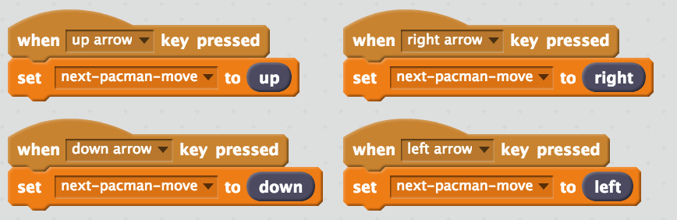

1. Modify the custom block “**pacman-move**” to use the move choices you created 用你创造的移动选项修改” **pacman-move**”自定义区块

*Drag the “up”, “down”, “left” and “right” blocks from your “pacman” project into the boxes in the script like in the picture below.*

*把****“****pacman “项目中的”上“”下“”左“”右“区块拉到脚本中，位置如图所示*

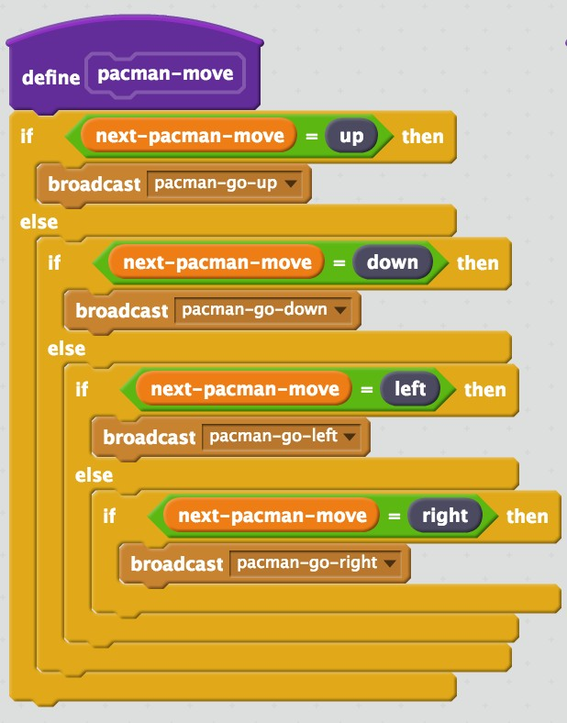

1. Update the custom block “**pacman-decision**” to add every move you make to your machine-learning training 将机器学习中每一步移动的数据添加到自定义区块“**pacman-decision**”中去。

*The purple “pacman-decision” block is ready for you in the starter project, at the top right of the Stage canvas. 紫色的“pacman-decision” 区块已经就绪，在场景的右上方*

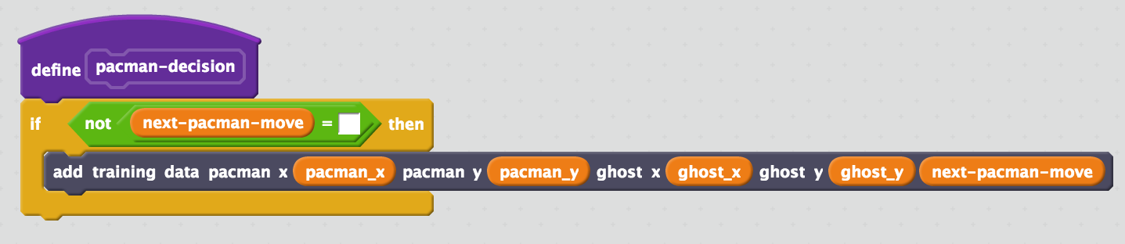

1. Train the computer! 训练计算机

*Click on full-screen again, and then the Green Flag. 点击全屏 点击绿旗子*

*Play a few games of Pac-Man, doing your best to avoid the ghost. The better you play, the better the computer has to learn from.*

*玩几局游戏，尽量做到最好。你玩的越好，电脑也就学的越好。*

1. Save your project 保存项目

*Click* ***File*** *->* ***Save project*** *点击****文件*** *->****保存项目***

*Name the file something like “pacman-learn.sbx” to remind yourself that this version of the project is the one to train Pac-Man.*

*将文件命名为“pacman-learn.sbx”以提醒自己这个版本是用来训练计算机的。*

***What have you done so far? 我们已经做了什么***

*You’re teaching a computer to play Pac-Man.*

*你在教电脑玩游戏*

*So far, you updated a Scratch Pac-Man game so that it can collect examples of how you play and add them to a set of examples. And you’ll use those examples to train a machine learning “model”.*

*到目前为止，你已经将游戏脚本更新，所以它能收集你的数据并将它们加到数据库中，用于学习。*

1. Go back to the training tool 回到训练工具
2. Click the “**< Back to project**” link, then click the “**Train**” button

*You should see the training examples you collected by playing Pac-Man.*

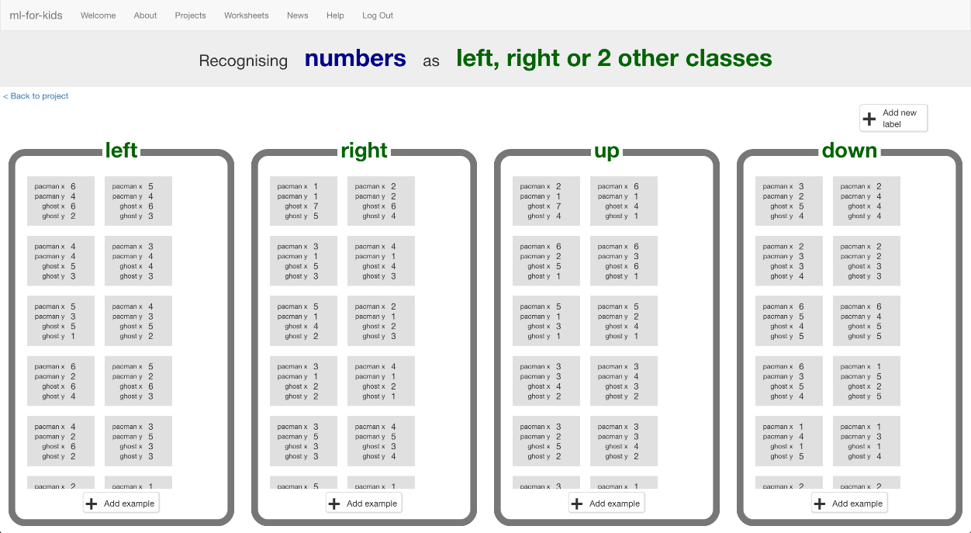

*点击“****回到项目”****链接，点击****“训练”****按钮 你可以看到你玩游戏时所产生的数据*

1. Click the “**< Back to project**” link, then click “**Learn & Test**”

点击**“回到项目”**链接，点击**“学习与测试”**

1. Click the “**Train new machine learning model**” button

点击“**训练新机器学习模型**”按钮

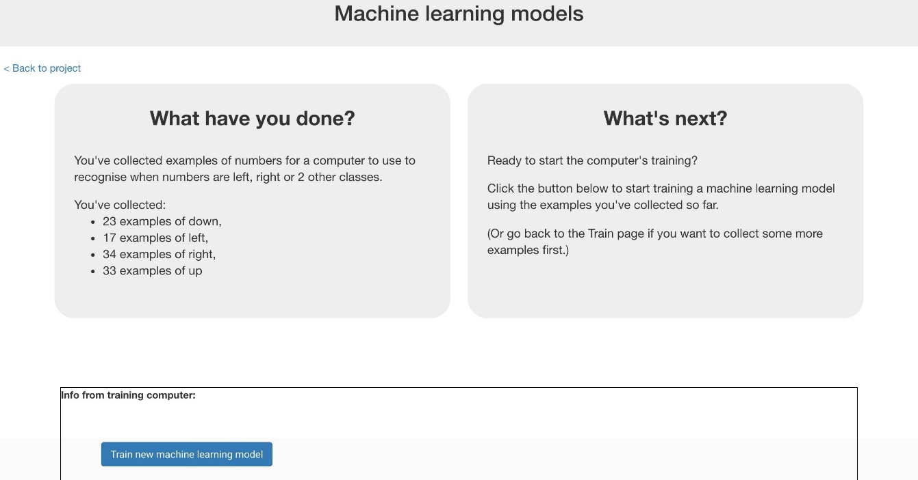

1. Switch back to the Scratch window. 回到脚本窗口

*If you accidentally closed it, you can get back to it by doing this:*

*如果你不小心关了，你可以通过以下方式重新进入：*

* + *Click the “****< Back to project****” link 点击“****回到项目****”链接*
  + *Click the “****Scratch****” button 点击****“脚本”****按钮*
  + *Click the “****Open in Scratch****” button 点击****“脚本中打开”****按钮*
  + *Open the Scratch project you saved before, with “****File****” -> “****Load Project****”*

*打开你之前保存的脚本项目 点击“****文件****‘ ->”****加载项目“***

1. Click on the Stage 点击场景

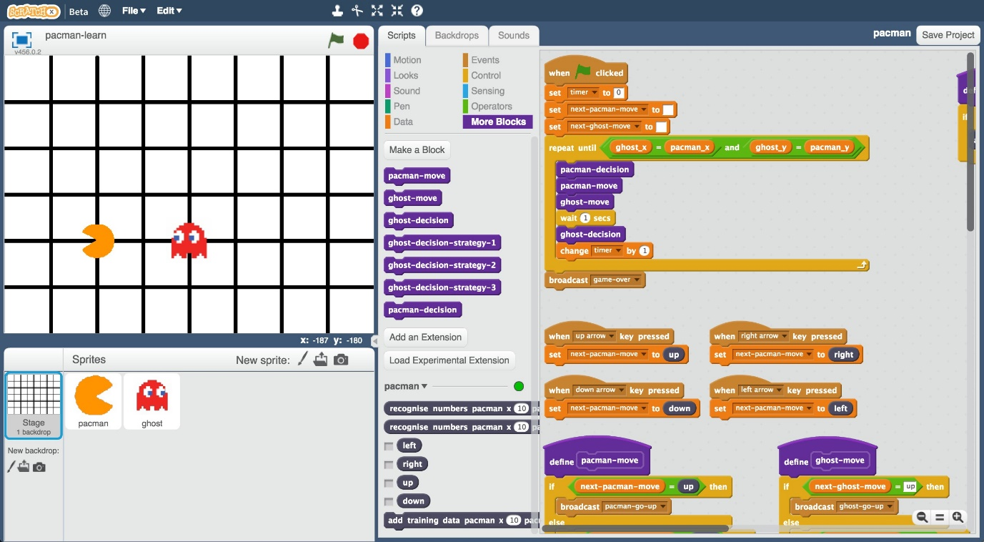

1. Delete the key press scripts because it’s the computer’s turn! *(Delete a script by dragging it back onto the palette, or right-click and choose “Delete”) 删掉按键脚本因为现在轮到电脑操作了（直接把它拖入调色板或者右键删除）*

*These are the scripts you don’t need any more: 这是你不需要的脚本*



1. Modify the custom “**pacman-decision**” block 修改自定义” **pacman-decision**”区块

*Instead of learning from what you are doing, now you want to use your*

*machine learning model 现在你希望用到机器学习模型，而不是你做了什么*

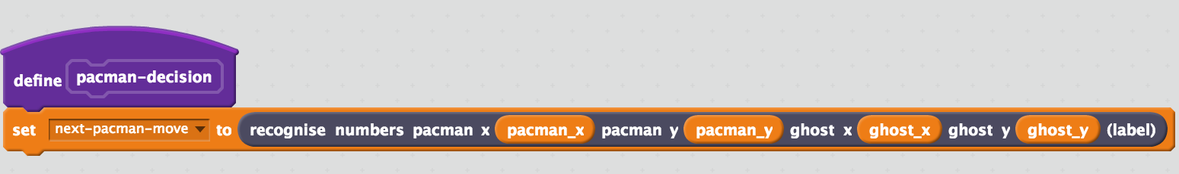

1. Modify the “Click Green Flag” script to remove “wait 1 second”. 修改“点击绿旗”这个脚本，移除“等待一秒”

*You want the script to end up looking like this: 最后脚本应如下*

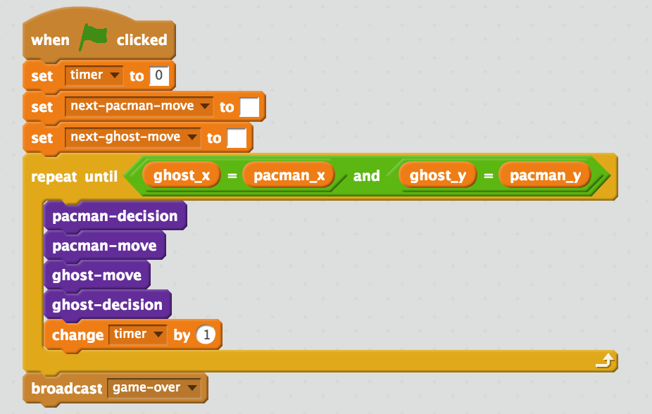

1. Save your project 保存项目

*Click* ***File*** *->* ***Save project*** *点击****文件*** *->* ***保存项目***

*Name the file something like “pacman-play.sbx” to remind yourself that this version of the project is where the computer controls Pac-Man.*

*将文件命名为“pacman-play.sbx”以提醒你自己这是控制小精灵的文件*

1. Test the computer! 检测计算机

*Click on full-screen again, and then the Green Flag. 点击全屏 绿旗子*

*Watch the Pac-Man you’ve trained try to avoid the ghost.*

*看你训练的小精灵*

1. Open the training project “**pacman-learn.sbx**”. 打开训练项目“**pacman-learn.sbx**”.

*Make sure you save your pacman-play project first!*

*请确保你已经保存pacman-play project*

*Click* ***File*** *->* ***Load Project*** *点击****文件*** *->* ***加载项目***

1. Train the computer some more by playing a few more games. 再玩几局
2. Go back to the training tool 回到训练工具
3. Go back to the “Learn & Test” page 回到“学习与测试”页面

*Click the “****< Back to project****” link, and then click “****Learn & Test****”*

*点击****“回到项目”****链接，然后点击****“学习与测试”***

1. Click the “**Train new machine learning model**” button again

点击“**训练新机器学习模型**“

1. Switch back to the Scratch window. 回到脚本页面

*If you accidentally closed it, you can get back to it by doing this:*

*如果你不小心关上了，你可以通过以下方式打开*

* + *Click the “****< Back to project****” link 点击“****回到项目****”链接*
  + *Click the “****Scratch****” button 点击****“脚本”****按钮*
  + *Click the “****Open in Scratch****” button 点击****“脚本中打开”****按钮*

1. Open the testing project “**pacman-play.sbx**” 打开测试文件**pacman-play.sbx**”

*Click* ***File*** *->* ***Load Project*** *点击****文件*** *->* ***加载项目***

1. Test the computer again 再次测试

*Did the computer do any better after more training?*

*计算机是否做的更好了呢*

**Tips**

***Getting stuck in a loop 不小心陷入循环***

*Sometimes the computer can get lucky, and find a circular route around the board that gets into a never-ending loop.*

*有时候非常幸运，你的电脑找到了一条环形路线，陷入了循环*

*When this happens, Pac-Man will never lose!*

*这种情况下，小精灵不会输*

*You can press the red stop button if you need to stop though.如果你想停下，请按红色按钮*

***Keep training 继续训练***

*The more examples the computer has to learn from, the better it will get. If you have time, play a lot of games and train a new model again.*

*数据越多，电脑做得越好。如果你有时间，不妨多玩几局。*

***Don’t be kind! 别仁慈***

*You might be tempted to go easy on the ghost when you’re playing against it.你可能玩的时候不认真*

*Don’t. It is learning from the way that you play. If you don’t complete a three-in-a-row when you can, you will be teaching it that it should do that.*

*不要这样做，电脑的学习过程取决于你的做法。如果你不尽可能长时间活下来，电脑也不会。*

*If you want it to get better quickly,* ***play as well as you can****.如果你想电脑能快速学好，****尽你所能玩***

**What have you done? 你做了什么**

You’ve trained a computer to play Pac-Man. 你训练了你的电脑玩游戏

You didn’t have to describe the rules to the computer. 不需要讲规则

You didn’t tell it that it should try to avoid the ghost.

你没告诉它要尽量躲避幽灵

You didn’t describe the boundaries of the board.

你没有向他说明游戏的界限

(The rules are in the Scratch game, but that doesn’t count – that wasn’t used in the machine learning model).

（规则在脚本中，但这不算，因为它没有被应用在机器学习模型中。）

Instead, you showed it how you play, by collecting examples of decisions that you made when you play.

通过采集数据，你教会电脑如何玩游戏

|  |
| --- |
|  |
| **Ideas and Extensions 延申** |
| Now that you’ve finished, why not give one of these ideas a try?  既然你已经完成任务了不如试试下面的想法  Or come up with one of your own? 或者你有什么想法  **Add another ghost 再加一个幽灵**  The game is beatable with only one ghost – Pac-Man can just carry on avoiding the ghost forever.小精灵可以躲避一个幽灵  But with a second ghost chasing after Pac-Man, it will get really hard.但是再加一个游戏就会变得困难  **Change the game board 改变游戏背景**  Try making the game board bigger. 将游戏区域变大  Or add obstacles that Pac-Man and the ghost will need to go around.添加障碍 |